Thomas Jefferson Medal
for Support of the SAR Knight Essay Contest

Hear ye, hear ye! The Knight Essay Contest makes a difference in the lives of patriotic young Americans every year by providing scholarships at the local, state and national levels to high school students who have researched and written outstanding essays relating to an event, person, philosophy or ideal associated with the American Revolution, the Declaration of Independence, or the framing of the United States Constitution. Recent winners have come from Connecticut, Virginia, New York, Wisconsin, South Carolina, Kentucky, Pennsylvania, Georgia, Missouri and California.
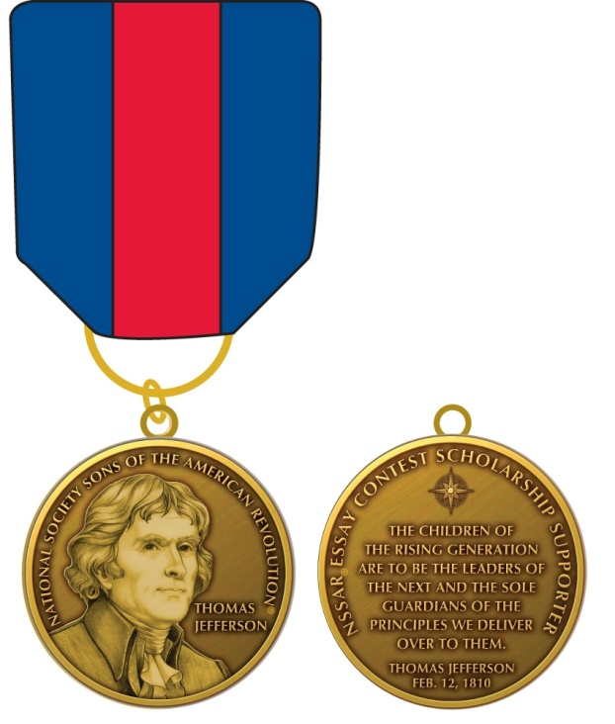
The Knight Essay Contest national-level awards are not competitive with similar contests. In 2020, the top prize was $5000. This amount is not commensurate with other national award contests. The proceeds from the sale of the Jefferson Medal will be used to enhance the essay endowment fund and increase the level of prizes that can be awarded in the contest. The medal is named for the author of the Declaration of Independence and one of the most important writers of the Revolutionary Era. The colors of the drape are derived from the heraldic arms assumed and used by Thomas Jefferson.

Please help the SAR educate future generations on the importance of the Revolution and its principles by contributing to the essay endowment fund TODAY! Contributions of $250 or more will be recognized with the medal and miniature. Each additional $250 donation earns an oak leaf cluster. A total cumulative donation of $1500 is recognized with a gold PATRON bar worn on the drape.

Donor Name: E-Mail:
Address: Phone:

Contribution Amount: $ Additional Pledge: $ over years.
Minimum initial contribution: $250. Make checks payable to SAR Foundation, with "Essay Endowment" in the memo line.
Mail To: James Lindley 510 13th Ave, Kirkland, WA, 98033-5601

THANK YOU FOR SUPPORTING THE SAR YOUTH ESSAY CONTEST!

