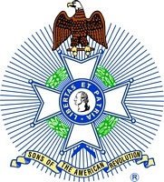

The NATIONAL SOCIeTY SAR,
The kINgS mOuNTAIN ChApTeR, NC SOCIeTY SAR
ANd
The dANIeL mORgAN ChApTeR, SC SOCIeTY SAR
INvITe YOu TO ATTeNd The
236Th ANNIveRSARY Of The bATTLe Of kINgS mOuNTAIN

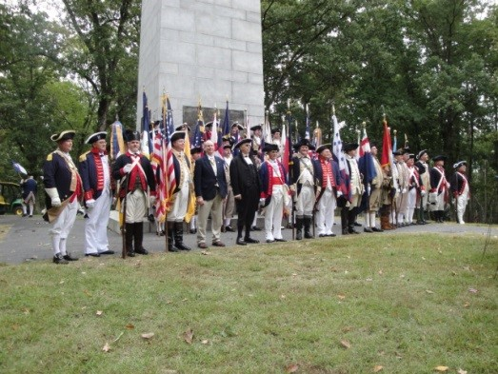

Friday, October 7, 2016 at 11:00 am
Kings Mountain National Military Park Blacksburg, SC

SAR, DAR, C.A.R. and other patriotic and lineage societies & chapters are invited to participate in a formal wreath laying ceremony at the United States' Monument. Participants presenting a wreath must deliver it to the Visitors Center no later than 9:30 am on October 7th for labeling and transportation to the monument. Transportation will be provided for those needing assistance to the monument. Continental, militia or period attire is encouraged.

Please complete and return the registration form provided on the following page and no later than Saturday, September 24th for the registration to be included in the printed program. Registration forms should be returned to Doyle Campbell at either: doylecampbell@carolina.rr.com or 1407 Merrimount Ave, Kings Mountain, NC 28086 .

Questions about the event can be directed to either Doyle Campbell or Mark C Anthony (mcgt90@bellsouth.net).

The Courtyard by Marriott located at 110 Mobile Dr, Spartanburg, SC 29303 is the official hotel for the 2016 Kings Mountain anniversary. A room rate of $121.00 plus tax is available. The hotel can be reached at 864-585-2400. A link to the reservation site will be made available in August. The deadline for making a reservation at this rate is September 15th. Additional hotels are available in Gaffney, SC, Gastonia, NC or Kings Mountain, NC.

Directions to Kings Mountain National Military Park (The park is located on South Carolina Highway 216):
- From Spartanburg, SC, take Interstate 85 NORTH to North Carolina Exit #2 and turn RIGHT. The Visitors Center is located approximately 5 miles on the left.
- From Charlotte, NC, take Interstate 85 SOUTH to North Carolina Exit #2 and turn LEFT. The Visitors Center is located approximately 5 miles on the left.

Version: 062816-6.30

The following is a listing of the events associated with the anniversary commemoration.

Thursday, October 6th
4:00 pm South Atlantic District, National Society SAR District Meeting
Courtyard by Marriott, 110 Mobile Dr, Spartanburg, SC
5:15 pm Kings Mountain Reception
Courtyard by Marriott, 110 Mobile Dr, Spartanburg, SC
6:00 pm The Night before Kings Mountain
Cowpens National Battlefield, 4001 Chesnee Hwy, Gaffney, SC 29341
Presented by the Overmountain Victory Trail Association

Friday, October 7th
9:30 am Deadline for delivery of wreaths to Kings Mountain Visitors Center
10:00 am Dedication of the marker to African American Patriots-NCSDAR
11:00 am Wreath Laying Ceremony at the United States Monument
3:00 pm Arrival of the Overmountain Victory Trail Marchers / Commemoration Ceremony

Kings Mountain Wreath Registration

Registration forms should be returned to Doyle Campbell at either: 1407 Merrimount Ave, Kings Mountain, NC 28086 or doylecampbell@carolina.rr.com.

Deadline for registration so that it will appear in the printed program is Saturday, September 24th.

Society Name: ___________________________________________
Chapter Name: __________________________________________
Name of Presenter: __________________________________ Title: _________________________________ Wreath Dedicated to: ______________________________________

Version: 062816-6.30

