Grave marking Manual
Version 6
James H. Wood
Chairman, Patriot Records Committee Sons of the American Revolution
Louisvile, KY
March 2, 2019
Contents
1. Introduction 2
2. Acknowledgements 2
3. Definitions 2
4. What is a Patriot Grave marking? 2
5. Individuals involved in a Grave Marking 3
6. Order of Service for a Grave Marking 5
7. Markers used for a Grave Marking 6
8. Approach when the grave site is not known for a patriot 7
9. Approach when a Patriot Grave Marker is not installed 7
10. Approach when all the graves in a cemetery are dedicated 8
11. Health and Safety considerations in a service 8
12. Suggestions on conducting a grave marking service 9
13. Suggestions on coordinating with the Daughters of the American Revolution in a grave marking 10
14. Approach when the grave site of a Compatriot/Member is marked 10
15. Approach for marking the grave site of an SAR member who is a Medal of Honor recipient 11
16. Suggestions for revisions to the Grave Marking Manual 11
17. Grave Marking Medal credit requirements 11
APPENDIX A - Patriot Graves and Biographies Report form 12
APPENDIX B – Example of a Pre-Event Press Release 13
APPENDIX C – Example of a Post-Event Press Release 14
APPENDIX D – Example of a Grave Marking Service 17
APPENDIX E – Example of a Grave Marking Service Program Handout 21
APPENDIX F – Other Grave Marking services handouts 23

1. Introduction

The purpose of this manual is to provide members of the National Society, Sons of the American Revolution (SAR) general information and guidelines for the activities involved with the marking of the grave of a Patriot from the American Revolution or a deceased member of the SAR. Individual state societies may have additional information and guidelines for grave markings conducted within their states.

2. Acknowledgements

The effort and input of the individuals in the Patriot Records Committee is acknowledged in the creation of this handbook. Their experience in marking Patriot and compatriots graves is reflected in the information provided.

3. Definitions
(a) A Patriot Grave marking is defined in paragraph 4
(b) A Patriot memorial service is a service conducted in the same manner as a Patriot Grave Marking but does not involve an unveiling of a new grave marker. It is not considered the same as a Patriot Grave Marking unless it is not possible to install a grave marker.
(c) A Compatriot Grave Marking Service or Memorial Service is a service conducted in the same manner as a Patriot Grave Marking but is held for a fellow member of the SAR who has passed. It is not considered the same as a Patriot Grave Marking and should be documented on a separate document for Compatriot Grave Marking Medal purposes.

4. What is a Patriot Grave marking?
A Patriot Grave Marking is a service conducted by the Sons of the American Revolution honoring a Patriot from the American Revolution with an unveiling of a new grave marker or lug. The service involves elements from:
(a) A US Military funeral
(b) A Church funeral
(c) The traditions, wishes and customs of the Patriot’s family
(d) The traditions, wishes and customs of the organization conducting the service
(e) The customs, wishes and traditions of the location of the grave site to include the church where the grave is located if appropriate.
(f) The items in this SAR instruction manual
There is not one exact order for the service honoring a Patriot since the requests of all elements are considered in organizing the service. The traditions and customs for a service may vary depending on the physical location where the service is conducted as well as the individuals and organizations involved. Other Patriot organizations, such as the Daughters of the American Revolution, may conduct a Patriot Grave Marking service and the SAR may be invited to participate. In this event, the protocols of the other organization would be followed by the SAR members involved in the grave marking.

5. Individuals involved in a Grave Marking
The following are the key individuals normally involved in a Patriot Grave Marking Service:

(a) Organizer/Commander. This is the individual who is in charge of the service and is the overall coordinator for all individuals and organizations involved. He may be the Chapter President, the Chapter Committee Grave chair or another individual in the chapter who is in charge of the event. He is always present in a service because there must be someone who is overall responsible to plan, set up and conduct the service. The responsibilities include, but are not limited to, these items in this check list:

(1) Locating the grave site of the Patriot to be honored. The grave may be located by the organizer or it may have been located by the efforts of the chapter involved in planning the service or by a descendant of the Patriot.
(2) Obtaining permission for the service to be conducted from the owner of the grave site. This may require a family member’s permission depending on the rules of the cemetery where the grave site is located. This may include contacting the church that owns the cemetery where the grave site is located and obtaining permission from the cemetery committee.
(3) Obtaining the proper marker(s) and have them installed prior to the service. A decision must be reached during the planning for the service on who will pay for the marker and its installation. The family may pay for the cost of the marker, the chapter may pay the cost or it may be shared among several different organizations and individuals. Often times the family requests for the Patriot’s grave to be marked and pays for the marker.
(4) Inviting the SAR participants in the service to attend and assign their tasks. Others that may be invited to attend and participate are the Boy Scouts, JROTC, veteran groups, Daughters of the American Revolution, re-enactors and others who have an interest.
(5) Securing the involvement of the family as appropriate and acting as liaison with the family members.
(6) Organizing the program and having it printed for the service. Appendices E and F at the end of this manual include examples of programs from various states.
(7) Developing an invitation list for the service and sending invitations to the organizations and individuals on the list. This would include, but not be limited to, local patriotic organizations and interested parties.
(8) Issuing pre-service and post-service publicity to the local media and appropriate SAR publications.
(9) Reviewing and planning for the safety issues that are involved for the location where the service is being conducted and appointing a safety officer for the service.
(10) Reporting the information about the Patriot’s Grave to the Patriot Records Committee as required. Use the Patriot Graves and Biographies for in Appendix A.
(11) Ensuring the Rifle Squad follows all safety procedures, if included.
(12) Serving as the master of ceremonies for the services or appointing someone to serve in this capacity. The master of ceremonies conducts the ceremony and makes all introductions, watches the time and offers closing remarks before the benediction. He calls the individuals who will present wreaths at the grave site (rendering honors).

(b) Chaplain or Minister. This is the individual who provides the invocation and benediction for the service. This Chaplain may offer remarks as is the custom of the Patriot’s family. Sometimes the Minister is from the church where the Patriot’s grave is located. The minister of the church where the Patriot’s grave is located, if applicable, should be invited to participate in the service. The chaplain’s role can be fulfilled by the chapter, state or national chaplain or a local minister. The Chaplain leads the flag carriers or color guard into the service when the colors are presented and retired.

(c) Speaker(s). This is the individual(s) who has a speaking part during the service. Some of the tasks that may perform include but are not limited to:

Lead the Pledge of Allegiance
Lead the SAR Pledge
Offer welcome remarks
Offer remarks about the Patriot being honored
Dedicate the installed marker
Lead the SAR Recessional

(d) Flag Carriers/Color Guard. These are the individuals who carry the flags used during the ceremony. The flags normally carried are the United States flag, the local SAR chapter flag and the local state flag. Other flags may be carried as available and appropriate for the location. Examples of other flags are local battle flags, early flags carried in the American Revolution and state and chapter flags of the SAR chapters involved in the ceremony. These individuals may be part of the chapter or state or national color guard but often are members of the chapter conducting the ceremony. Often they appear in Revolutionary War or period uniform but this is not a requirement. The individuals involved with the colors are:
(1) Color guard Commander. He may carry a sword, a rifle, musket or a Spontoon. He commands the color guard and gives the commands for the unit. He makes the decision on how the colors are presented and retired. He is in command of any volleys fired.
(2) Flag carriers. These men carry the flags involved in the service. In marching order, the flags are United States flag(s), State flag(s), SAR (District, State then chapter(s)), followed by other Societies and then any Regimental or Historical Flags.
(3) Riflemen/Musketeers. These men carry a period rifle or musket and provide armed guard for the colors. Their position is in front of (to the right of) the United States flag and behind the column of flags (to the far left). When the situation allows, they fire a volley after the service in honor of the Patriot. They may also perform a Mourn Arms salute. Upon retiring the colors, the Mourn Arms salute is performed. This consists of bringing the muskets to Present Arms with the muskets raised high and the muzzle slowly to point straight down. Next, the elbows are lowered to the sides and then all heads are lowered to the musket butt. After a moment of silence for the departed, the Commander gives a signal to raise heads following the Benediction.
(4) Drum/Fife. This individual provides a cadence for the entire color guard and marches in front of the column.
(5) Safety Officer. When rifles or muskets are used in a service, a competent person must be appointed as a safety officer to inspect the muskets prior to firing. In most situations, appropriate permission must be obtained before muskets are fired in a service.
(6) When there is no color guard present for the service, the flags are pre-posted before the ceremony begins and then removed after the ceremony closes. The state or national color guard manual should be consulted for additional protocols.

Other individuals that may be involved in the service depending on how it is conducted:

(e) Musician. This is the individual(s) who sing the Star Spangled Banner, other patriotic songs or plays music as requested by the patriot’s family. While not a part of the service in the 18th century, taps are often played at the end of a Patriot Grave service in keeping with a modern military service. This would be played by the musician in the service.

(f) Photographer. This is the individual who takes pictures of the ceremony and group pictures after the service.

(g) Traffic Director. This is the individual(s) who direct attendees where to park and help provide direction before and after the service.

(h) Keynote speaker. This individual may be present in the ceremony and is the main speaker during the service. There should be only one Keynote speaker for a service. This person gives the main address or presentation. Other speakers or distinguished guests should limit their remarks to a very few minutes when a keynote speaker is present in the service. Politicians are discouraged from speaking unless they are presenting a proclamation because the service is to honor a Patriot.

(i) Wreath Registrar. This is the individual(s) who is responsible for verifying the individuals present who will render honors and recording their presence.

6. Order of Service for a Grave Marking
The following is a typical order of service for a Patriot Grave Marking:

Call to Order
Presentation of Colors
Invocation by Chaplain or Minister
Pledge of Allegiance to United States flag
SAR Pledge by SAR Members
Welcome and Introduction to SAR
Introduction of Dignitaries and Participants
Remarks
Introduction of Patriot’s descendants present
Dedication of SAR Grave Marker (Unveiling of the marker)
Presentation of Wreaths at Grave Site (Rendering Honors)
SAR Recessional by SAR Members
Benediction by Chaplain or Minister
Retirement of Colors

Other activities may take place within the service depending on the request of the family and the local customs and the organizations involved. Examples of these can be seen in the sample program of services shown at the end of this manual. Note, in the event of inclement weather, the ceremony is conducted as planned since there is not sufficient time to notify everyone. Provision for inclement weather should be included in the planning for the service.

7. Markers used for a Grave Marking
The following are examples of Patriot Grave Markers and suggestions on their installation:

Patriot Bronze Marker

- Installed on a headstone. SKU 0601L This is a marker (called a large lug) that is constructed to be installed on a grave marker or headstone. It is available in a regular size and a small size from the SAR store. The large size is the same size as a Patriot Bronze Marker that is installed in the ground on a medal stake and is most often used on an upright headstone. The smaller marker is most often used on a flat grave marker. The marker should be installed by a monument company that is familiar with the process. The marker should not be installed on very old headstones as they are usually not strong enough to take the installation. There is also a small lug available SKU 0601C.
- Installed in the ground. SKU 0601S This is a Patriot Bronze Grave Marker that is available from the SAR Store that consists of a metal stake, a bronze marker and screws to attach the marker to the stake. To install the marker, a hole is dug in the ground and cement is placed in the hole then the metal stake is placed in the cement. The cement is allowed to dry overnight then the bronze marker is placed on the metal stake using the screws provided in the kit. The stake is normally installed next to the headstone. The marker is often not used today due to bronze metal being stolen from cemeteries and the difficulty of mowing around the stake.

(b) Patriot Marble/Granite Marker - Installed in the ground. This is a marble/granite marker that is available from a third party that is installed in the ground by the existing headstone. A hole is dug in the ground, cement is poured in and the marble is set into the cement. This marker is more common today because it allows for easier maintenance by grounds keeping and it is not often stolen.

(c) Compatriot (Member) Bronze Grave Marker

- Installed on a headstone. SKU 0602L This bronze marker (a lug) is available from the SAR store and is designed to be installed on a headstone or marker. It is installed the same as a Patriot Grave Marker and should be done by a monument company.
- Installed in the ground. SKU 0602S . This marker is available from the SAR store and is installed in the same manner as a Patriot Bronze marker.
- Installed on a Cremation Vessel. SKU 603C This bronze marker is available from the SAR store and is designed to be installed on a crematoria vessel by the funeral company. This marker can also be installed on a flat marker for Memorial parks for a compatriot.

(d) Compatriot marble/granite marker - Installed in the ground. This marker is available from a third party and is designed to be installed in the ground by the headstone or grave marker. A hole is dug and cement is poured in and the marble marker is placed in the cement. This marker is most often used today because it allows easier grounds keeping.

8. Approach when the grave site is not known for a patriot
Examples when the grave site of a patriot is not known would be burial at sea, when the location has been lost due to time, when the individual was buried on the battle field in a mass grave or in an unmarked grave and when the Patriot was buried in an unmarked grave. These are the suggested approaches to follow when a grave site is not known for a Patriot:

(a) Approach a nearby church with a cemetery and request permission for a marker to be installed in an unused portion of the cemetery. Conduct the service at this location and note that this marker is installed here but the actual grave site is not known.
(b) Conduct the service at or near the location of the historic battlefield. A marker may or may not be installed depending on whether it is practical and desired and permission can be obtained.
(c) Conduct the service in a local cemetery and note during the service that the patriot was buried at sea or the specific grave site is unknown. The service could be conducted in the Patriot’s family church if that is desired by the family. A marker may or may not be installed depending on the desires of the family.
(d) When the cemetery is known where the Patriot was buried but the location of the grave site has been lost, then the service is conducted as noted above. A marker may be placed somewhere in the cemetery or the service may be conducted and a marker not installed.

9. Approach when a Patriot Grave Marker is not installed

Examples where a grave marker might not be installed for a service:
(a) When the Patriot’s grave is constructed such that it is impractical for a market to be installed. This could be due to the amount of cement around the grave site which precludes either a bronze or stone marker installation.
(b) When the current headstone is fragile and the installation of a bronze marker on the headstone is not practical and the installation of a marble marker is not permitted.
(c) When the rules of the cemetery do not allow a marker to be installed.

The approached followed when this situation happens is the service is conducted as outlined above and no mention is made of the installed marker in the service.

10. Approach when all the graves in a cemetery are dedicated
Sometimes a decision is made to dedicate all the Revolutionary War graves in a cemetery in a single service. Normally in this situation one marker (or monument) is installed that lists all the Patriots that are buried in the cemetery. This monument would also contain the SAR Patriot Grave marker. In this situation, the service would be conducted as outlined above and the names of all the Patriots that are being honored would be noted in the service and the program. The single marker (monument) would be dedicated rather than individual markers at each grave site. Often times the marker is a monument that lists the individual names of the Patriots and has the SAR Patriot Grave marker installed on it. In the event it is not practical to install the marker at the cemetery, then it should be installed at nearby public place where the Patriots can be recognized. In some situations, the service will dedicate the cemetery and no marker will be installed. In such situations where no marker is installed, the service will be conducted as noted above and no mention would be made of the marker. If no marker is installed when all the patriot graves in a cemetery are dedicated, then the service is not classified as a Patriot Grave Marking.

11. Health and Safety considerations in a service
When planning for a Patriot Grave Service, consideration must be made for the health and safety of the participants and plans made for possible safety issues. The services are often in old cemeteries and this presents a unique situation where extra precautions should be taken both prior to and during the service. One compatriot should be placed in charge to make sure proper precautions are taken in planning for the service. The following is a check list of possible items to consider in planning for the service:

(a) Request the local EMS have a vehicle present during the service for any emergencies
(b) Conduct a safety inspection on any muskets used and have a designated compatriot who is familiar with musket procedures in charge of the firing during the service if it is used
(c) Designate compatriots to be responsible to assist individuals who may need help in walking to the service and in rendering honors
(d) Have a first aid kit available
(e) Have chairs available for individuals to use during the service
(f) Have water available if the weather may be hot
(g) When tents or awnings are used they must be inspected before use to make sure they have been installed correctly
(h) Plan for cleanup of all trash after the service
(i) Inspect any public address systems that are used for electrical safety
(j) Have the local sheriff or police provide traffic control if necessary

12. Suggestions on conducting a grave marking service
The following are suggestions in organizing and conducting a service:
(a) A service should be organized to be completed within thirty minutes
(b) A program should be printed and given to each person in attendance at the service as it allows everyone to follow the service and serves as a keepsake for the family
(c) A descendant of the Patriot should be invited to speak during the service
(d) A press release should be sent to the local media about the service before the service is conducted and after the service is conducted
(e) The order of presenters when honors are given (when wreaths are presented) and the SAR is in charge of the ceremony is:
(1) Host State Officer
(2) National Officers
(a) Sons of the American Revolution
(b) Daughters of the American Revolution
(c) Order of the Cincinnati
(d) Society of Colonial Wars
(e) Sons of the Revolution
(f) Colonial Dames of XVII Century
(g) Children of the American Revolution
(3) State Officers
(a) Sons of the American Revolution
(b) Daughters of the American Revolution
(c) Order of the Cincinnati
(d) Society of Colonial Wars
(e) Sons of the Revolution
(f) Colonial Dames XVII Century
(g) Children of the American Revolution
(4) Chapters
(a) Sons of the American Revolution
(b) Daughters of the American Revolution
(c) Order of the Cincinnati
(d) Society of Colonial Wars
(e) Sons of the Revolution
(f) Colonial Dames XVII Century
(g) Children of the American Revolution
(5) Other Patriot Organizations
(6) Sons of the American Revolution Ladies Auxiliary
(7) Family Members
(8) Government Officials

(f) When the SAR is participating in a Grave Marking Service and another organization is in charge, then the order of presenters when honors are given, is determined by the organization in charge.
(g) Often wreaths are placed at the grave site ahead of the service rather than carried to the site when honors are given. This allows the organizers of the service to place the wreaths in a reasonable order and is safer for those rendering honors. Only one wreath is presented for each position unless it is by a family member who places wreaths for their patriotic ancestor.
(h) When muskets are used in a service, a competent person must be appointed as a safety officer to inspect the muskets prior to firing and after firing. Appropriate permission must be obtained before muskets are fired in a service.
(i) Consideration should be given to provide for refreshment following the service in the cemetery hall or local church basement. This is often coordinated by the family or the cemetery committee of the church involved in the service.

13. Suggestions on coordinating with the Daughters of the American Revolution in a grave marking
When a Grave Marking service is being planned, the individual in charge of the service should contact the Regent of the local DAR chapter and inform her about the ceremony and invite her and the chapter to attend and render honors. If there are several DAR chapters in the area, each should be contacted and invited. In addition, through the state SAR liaison to the DAR, contact should be made to the State DAR President about the ceremony providing her an opportunity to attend to render honors.

14. Approach when the grave site of a Compatriot/Member is marked
This is the situation when a request is made to install a marker (SAR member marker) for a compatriot at the grave site of a member. In this situation, the service is conducted as noted above and the marker installed is one designated for a member rather than one for a Patriot. This is classified as a Compatriot Grave marking and not a Patriot Grave Marking. In addition the organizer of the event should obtain from NSSAR Merchandise certificate (0460) and folder (0420M) to be presented to the family during the service. When a compatriot is buried in a National Cemetery, an SAR marker will not be allowed. A suggestion is to conduct a normal service and obtain a SAR Member medallion from NSSAR Merchandise and present it to the family during the service. Also, a United States flag may be ordered through the compatriot’s congressman to be flown over the U. S. Capital and presented to the family during the grave marking service.

15. Approach for marking the grave site of an SAR member who is a Medal of Honor recipient

This is the situation when a request is made to install a compatriot marker at the grave site of a member who is a recipient of the Congressional Medal of Honor. In this situation, the service is conducted as noted above and the marker installed is one designated for a member rather than for a Patriot. In the service it is noted the member received the nation’s highest military honor. This is classified as a Compatriot Grave marking and not a Patriot Grave Marking.

16. Suggestions for revisions to the Grave Marking Manual
Suggestions for revisions and updates to the Grave Marking Manual should be sent to SAR National Headquarters Attention Chairman, Patriot Records Committee.

17. Grave Marking Medal credit requirements
- No more than five grave markings may be credited from the same location on the same date.
- After 28 Sep 2018, an SAR Compatriot must contribute a minimum of $60 to each grave marking ceremony to receive credit towards the grave marking medal when the Nominee Role is identified as “Funding.” Documentation from the chapter president conducting grave marking that the Funding was for a specific ceremony must be included with the Grave Marking Medal application.
- Grave marking medal credit may only be achieved when marking the grave of a patriot/compatriot for the first time. Only members participating in the original grave marking are eligible.
- Unknown patriots buried in a mass grave may only be documented as one Ceremony on the Grave Marking Medal form no matter how many have been buried in the grave. A picture of the monument/plaque identifying the unknown soldiers/patriots must be included with the Grave Marking Medal application.
- When marking a grave, a picture of the grave and marker should be included as an additional attachment long with the “Patriot Graves and Biographies Report.”
- Graves marked must be for patriots included in the Patriot Research System (PRS). The Patriot number should be added following the patriot’s name. If the patriot has not been previously recognized in the PRS, the individual/chapter/society marking the grave must complete a “Patriot Graves and Biographies Report” that includes specific service details the patriot conducted to earn the designation as Patriot and reference sources for the patriot’s service.

APPENDIX A - Patriot Graves and Biographies Report form
The organizer/commander for the service in coordination with the State Patriot Records Committee Chairman should report the service using the current Patriot Graves and Biographies Form to PatriotGraves@sar.org. This updates the SAR database and provides the information to other SAR members and researchers.

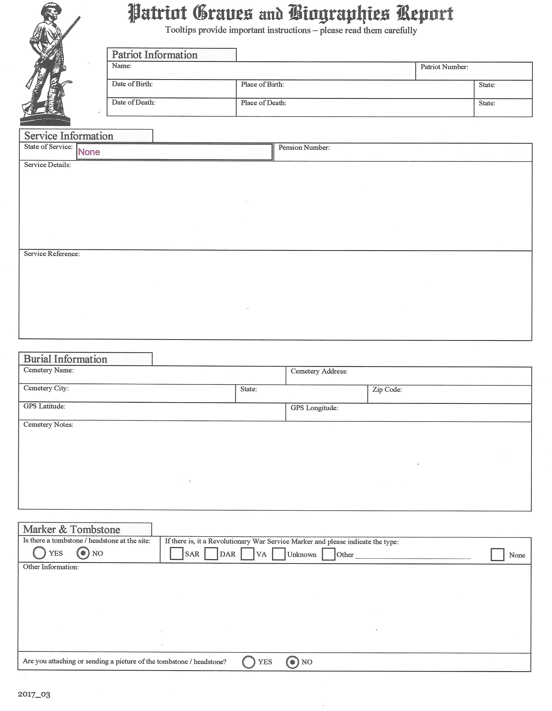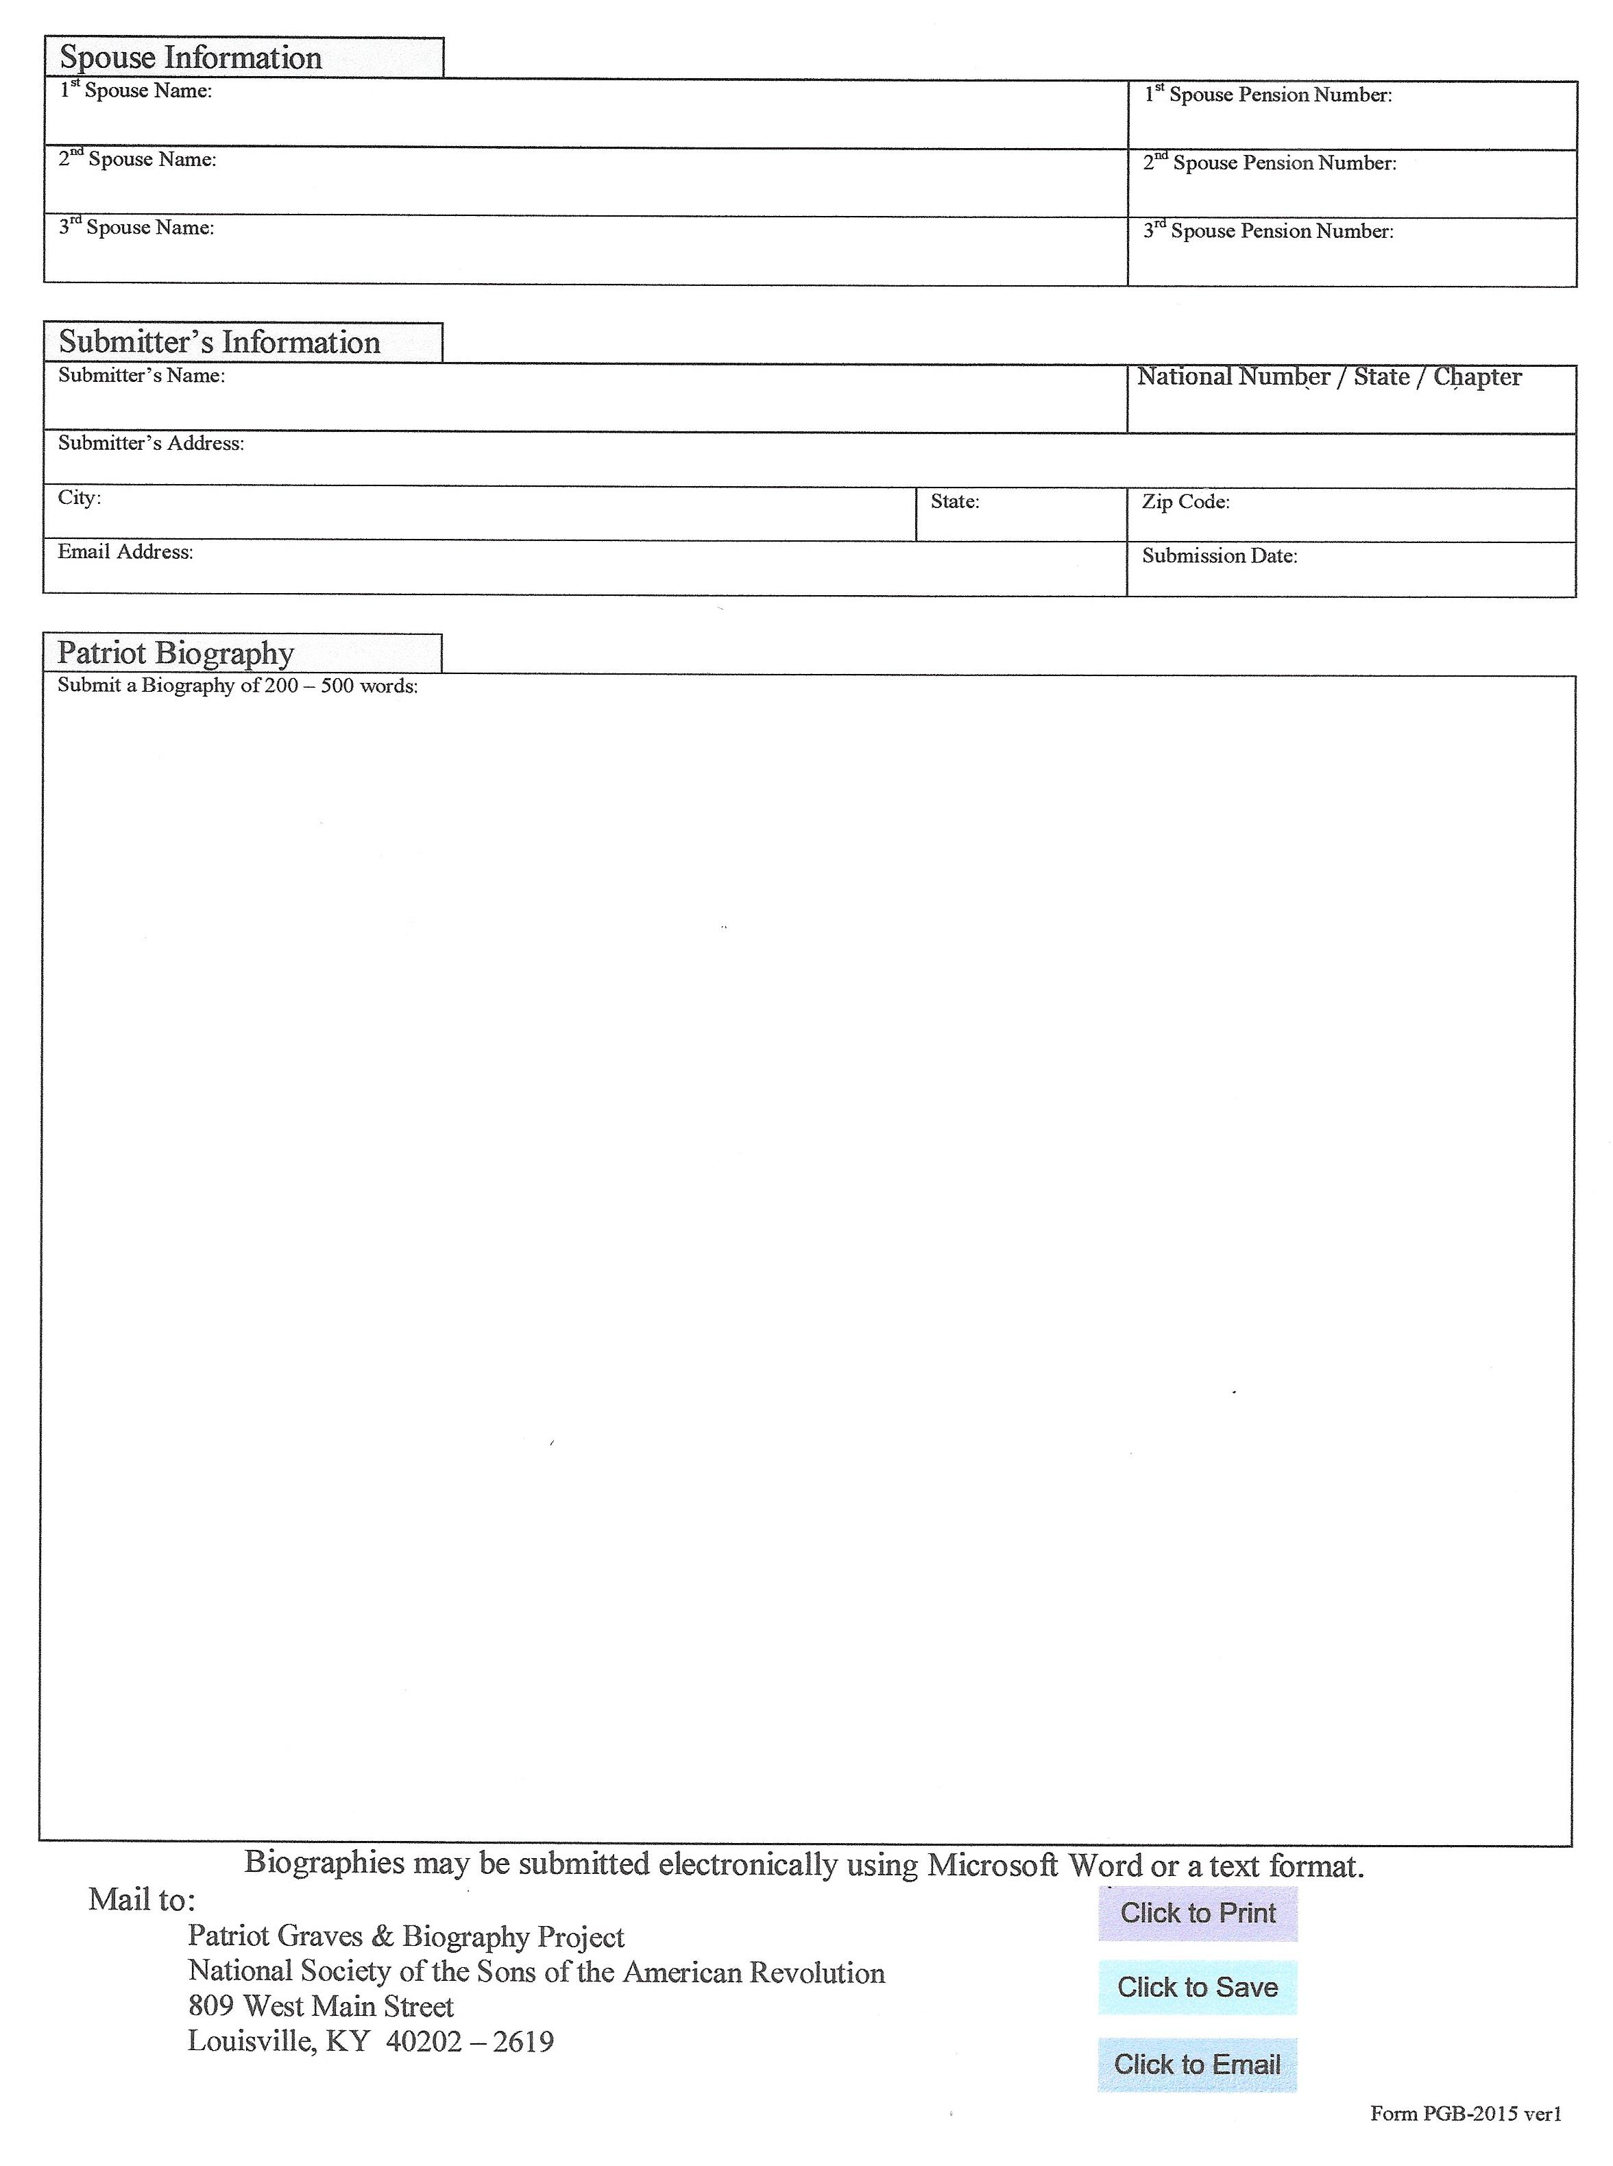

APPENDIX B – Example of a Pre-Event Press Release

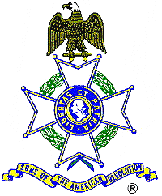For Immediate Release
American Revolution Patriot to be Remembered
At 11:00 A.M., Saturday, March 29, 2008, the Sons of the American Revolution will host a ceremony honoring Revolutionary War veteran Jeremiah Lumsden by installing a memorial marker at his grave in Jasper County, Georgia.
The ceremony, featuring a presentation of colors by the SAR State Color Guard, a Fife and Drum duo, a Bagpiper, and a Musketeer (all dressed in Revolutionary War period uniforms), will be held in the Kelly Family Cemetery near Shady Dale, Georgia..
A family descendant and SAR member Lieutenant Colonel Donald Gunn, U.S. Army, will present the biography of his ancestor. The public is invited to see this colorful and dignified tribute to one of America’s first veterans.
Directions: North of Shady Dale on highway142 Begin looking for Barr Bridge Road on the left and after passing Kline Road (on the left) look for distinctive flags on the right for access to the cemetery.
The Sons of the American Revolution and Daughters of the American Revolution are national patriotic, historical and educational societies whose members are direct descendents of the patriots who earned our independence. For additional information or directions contact George Thurmond at 770-475-1463.

APPENDIX C – Example of a Post-Event Press Release
For Immediate Release
Revolutionary War Patriot Captain John Collins was honored at a recent service with a grave marking by the Piedmont Chapter, Sons of the American Revolution. The dedication service was conducted at the Mars Hill Cemetery in Acworth. Representatives from numerous patriotic organizations also participated in the service. The dignity of the occasion was highlighted by Piedmont member, John Lee Mortison piping the Georgia Society Color Guard and Master of Ceremonies, Roger Lamb into position. The Color Guard was dressed in period uniforms. Drum and fife music was played during the unveiling of the marker and the presentation of wreaths, including several by Regents from Daughters of the American Revolution chapters, Sons of the American Revolution chapters and by the Georgia Society, Children of the American Revolution (CAR) President, Kinsley Belew of Fairmount, Georgia.
A Honor Guard was furnished by Junior Air Force ROTC Students from Sequoyah High School. Escort Officer, Bob Galer, Chairman of the National Society, Sons of the American Revolution Graves Committee, traveled from Columbus to participate in the service. Galer wore his Militia Uniform. Bill Barnes, dressed in a Marine Revolutionary War Uniform, also escorted those presenting wreaths at the grave site.
Acworth Mayor Marcia Andruzzi, Abbie Parks, Chairperson of the Acworth Society for Historic Preservation, Betty Parker, Chairperson, Cobb County Cemetery Commission and Ed Sterrett, President, Georgia Society, Sons of the American Revolution were special guests.
The grave stone was marked with a distinctive bronze marker which depicts the familiar Continental soldier with his musket, ready to defend his country. The marker consists of four arms and eight points, each point being decorated with a gold head. The source of the cross is the ancient chivalric Order of St. Louis. The cross is connected with a circular laurel wreath, a Napoleonic symbol recognizing faithful service and merit. The year 1775 is inscribed at the base - the year the “shot heard round the world” was fired at Lexington Green, Massachusetts. An American flag was appropriately placed at the rear of the marker.
Piedmont member Ed Hereford presented the biography of John Collins - a true American hero. John Collins was born on December 9, 1760 in Frederick County, Maryland. He served in the South Carolina Militia from May 10, 1776 to October 26, 1776 under Captain Robert McAfee and Colonel Neal. He was in a skirmish with the Indians on the Seneca River. He re-enlisted for a second tour under the same officers. In his third tour, Patriot Collins served as a private in the Camden District and as a substitute in Captain Thomas Barron’s Company, commanded by Major Francis Ross where he was in the Battle of Briar Creek.
Next, he enlisted in Captain Benjamin Harden’s Company of the North Carolina Militia commanded by Colonel Charles McDowell. He served from September 1779 as Orderly Sergeant under Captain John G. Lowman and Colonel Hampton. Immediately afterwards he was a Private, Sergeant, and Sergeant-Major under Captain John G. Lowman and Colonel Archibald Lyle. He was taken prisoner at the fall of Charleston, but later paroled. Collins went to Lincoln County, North Carolina where he was again captured by the Tories. He was sentenced to be hanged but escaped and joined the Militia. He participated in the Battles of King’s Mountain, Cowpens, Guilford Courthouse and Yorktown. He also served as an Adjutant Lieutenant in the Virginia Troops and a Captain in the South Carolina Militia and participated in the Battles of Orangeburg, Four Holes Bridge and Bacon’s Bridge. He received a pension for his service.
Patriot Collins married Phebe Sailors on November 30, 1786 and settled in Acworth with his son, Daniel. Pioneer John Collins and his wife are noted as founders of Acworth’s First Baptist Church in 1840. The Collins home still sits as it has for more than 150 years, atop a small rise at 4591 Collins Avenue. The home is located in the Historic District, which is the only listing of this type in Acworth. Patriot Collins died on March 8, 1852. His son, Daniel, is also buried at Mars Hill and is mentioned in his pension application.
Piedmont Chaplain, Bob Buck presented the dedication statement, indicating the significant contributions of Patriot Collins and drawing a comparison of his performance to three Patriots who were awarded the Military Badge of Merit.
Following the playing of Amazing Grace on the bagpipes, a black powder gun salute was fired by Militia Guard James Conerly to honor Patriot Collins whose voice has long been silent.
Over 200 years have passed since the Revolutionary War Patriots were successful in their fight for independence from Great Britain. The Sons of the American Revolution is an organization whose members carry out patriotic, historical and educational activities to perpetuate the memory and sacrifices of their ancestors who fought or aided in the American Revolution. One ongoing program is to locate and mark the final resting place of those who participated in the struggle for freedom. Any information which will assist in this program or inquiries about membership in the Sons of the American Revolution should be directed to _______________ or email___________
______________________________________________________________________________
END
Photographs are available upon request. Contact: ___________ (Phone) or email____________

APPENDIX D – Example of a Grave Marking Service
This is an outline for speakers at a grave marking. The verbiage is an example only; others may choose different phrasing as appropriate.
Grave Marking Service
for
Compatriots Dr. Lee W. Porter, Captain Robert S. Beckham, Rev Walser Allen
- SAR Official: Welcome and Greetings
President John Stewart: Compatriots, we meet at this time to commemorate one of our fellow members who has answered the last call to duty. If the past is indeed prologue, then a glimpse into the past can provide a source of wisdom and inspiration for the future. As we honor this compatriot today, let us be mindful of his service to our nation, and let us rededicate ourselves to the principles for which he held sacred. Color Guard, post the colors.
- Presentation of the Colors: SAR Color Guard (Color guard - Lower Cape Fear Chapter, NC)
- Invocation
Chaplain Charles Lewis: As we gather, O God, for this dedication today, we ask your blessing upon each of us. We thank you for this occasion as we honor the memory of Dr. Lee W. Porter, Captain Robert S. Beckham, Rev Walser Allen; we esteem his patriotism and courage, his faith and loyalty, and his willingness to sacrifice to make our world a better place. We thank you, too, for America and all patriots who have given us the liberties and privileges that we enjoy. May we be willing to serve you and our nation even as they did. May the ideals that we remember from the past sustain us today and safeguard us tomorrow. Amen
- Pledge of Allegiance to the flag – Compatriot Tom Pearson
- Introduction to the assembly of the Daughters of the American Revolution –Regent, Stamp Defiance Chapter, DAR- Jo Stroud
  - The DAR, founded in 1890 and headquartered in Washington, D.C., is a non-profit, non-political volunteer women's service organization dedicated to promoting patriotism, preserving American history, and securing America's future through better education for children.
  - DAR members volunteer more than 60,000 hours annually to veteran patients, award over $150,000 in scholarships and financial aid each year to students, and support schools for the underprivileged with annual donations exceeding one million dollars.
  - As one of the most inclusive genealogical societies in the country, DAR boasts 165,000 members in 3,000 chapters across the United States and internationally. Any woman 18 years or older-regardless of race, religion, or ethnic background-who can prove lineal descent from a patriot of the American Revolution, is eligible for membership.
  - Encompassing an entire downtown city block, DAR National Headquarters houses one of the nation's premier genealogical libraries, one of the foremost collections of pre-industrial American decorative arts, Washington's largest concert hall, and an extensive collection of early American manuscripts and imprints.
The American's Creed
(Authorized Version by William Tyler Page)
I believe in the United States of American as a government of the people, by the people, for the people; whose just powers are derived from the consent of the governed; a democracy in a republic; a sovereign Nation of many sovereign States; a perfect Union, one and inseparable; established upon those principles of freedom, equality, justice and humanity for which American patriots sacrificed their lives and fortunes.
I therefore believe it is my duty to my country to love it; support its Constitution; to obey its laws; to respect its flag; and to defend it against all enemies.
- Introduction of the assembly to the Society of the Sons of the American Revolution. Compatriot George Strunk, NC SAR State President
On the 100th anniversary of George Washington's inauguration as the first President of the United States, the “National Society of the Sons of the American Revolution” was founded at Fraunces Tavern in New York City. The date was April 30, 1889. The organization was an outgrowth of the previously established “Society of Sons of the Revolutionary Sires,” founded in 1876; and the Sons of the Revolution instituted in 1883; and the “Society of the Sons of the Revolution” organized in March 1889.
- SAR Pledge by SAR Members – Compatriot Bob Williamson
We, the descendants of the heroes of the American Revolution, who, by their sacrifices, established the United States of America, reaffirm our faith in the principles of Liberty and our Constitutional Republic and solemnly pledge ourselves to defend them against every foe.
- Life of Compatriot – Specific biography at each grave site
  - Dr. Lee Warwick Porter – Bob Williamson
  - Captain Robert Strickland Beckham – Tom Pearson
  - Rev Walser Allen – Gary O. Green
President Stewart: The Chaplain will preside.
Chaplain Lewis: Mr. President, Compatriots, I am at your service and shall endeavor to perform this solemn duty in the spirit of true Christian Faith. Mr. President, to whom should we look for help in life's battles?

President Stewart: "Our help is in the name of the Lord, who made heaven and earth."
Chaplain Lewis: Mr. Secretary, what assurance have we of a prolonged stay among the scenes and activities of this life?
Secretary Meyer: In 1st Chronicles 29:15 it says: "We are here for only a moment, visitors and strangers in the land as our ancestors were before us. Our days on Earth are like a passing shadow, gone so soon without a trace.”
Chaplain Lewis: Mr. Secretary, do you have a message of condolence?
Secretary Meyer: The Holy Bible tells us in Psalms 103:13-14: "The Lord is like a father to his children, tender and compassionate to those who fear him. For he knows how weak we are; he remembers we are only dust.”
Chaplain Lewis: And I, too, have a message of inspiration for all Compatriots and their families that should inspire us now, at this solemn moment, and all through life. This message is from Christ, the Head of the Church, who said: "I am the resurrection and the life; he that believeth in me, though he were dead, yet shall he live; and whosoever believeth in me shall never die." Compatriots, let us so live that when that last summons comes for us, we may depart this life
Let us pray: Our gracious heavenly Father, in silent reverence we recognize the truth of your inspired words; "I am the resurrection and the life: He that believeth in me, though he were dead, yet shall he live.” As Compatriots answer the last summons from you, we ask that you will look with mercy upon their families, and with your own tenderness console and comfort them. And now, our Heavenly Father, bless our country with freedom, peace and righteousness. Through your favor may we all meet at last before your throne in Glory All this we pray through Jesus Christ our Lord. Amen.”
- Decoration of the grave with wreath or other floral arrangement
  - Lower Cape Fear Chapter (Wilmington, NC), NC SAR – John Stewart
  - NC SAR & General George Washington Chapter SAR – George Strunk
  - Old North State Chapter-Dr. Charles Lewis
  - Stamp Defiance Chapter DAR – Jo Stroud

- Introduction of descendants and family members of the Compatriot in attendance or identify those that could not be at the service – President Stewart
  - Family members
  - Comments by any others in attendance
- Dedication of the Marker
President Stewart: We, the members of the Lower Cape Fear Chapter, North Carolina State Society, Sons of the American Revolution dedicate this American Flag to the glory of God and in recognition of the memory of Compatriot Porter/Strickland/Allen, a compatriot of the American Revolution.
Chaplain Lewis: Almighty God, as we go from here, may this marker remind all who pass by of the devotion and dedication of all who have made our nation great. May all be humbled and encouraged by this marker to esteem and perpetuate these virtues with our lives. May the peace of God, which surpasses all, guard our hearts and minds in the ties of friendship and unity of love, Amen.
- SAR Recessional by SAR members –Compatriot Green
Until we meet again, let us remember our obligations to our forefathers who gave us our Constitution, the Bill of Rights, an independent Supreme Court, and a nation of free men.
- President Stewart: “Color Guard Retire the Colors”

APPENDIX E – Example of a Grave Marking Service Program Handout
Program
Member Grave Marking Service
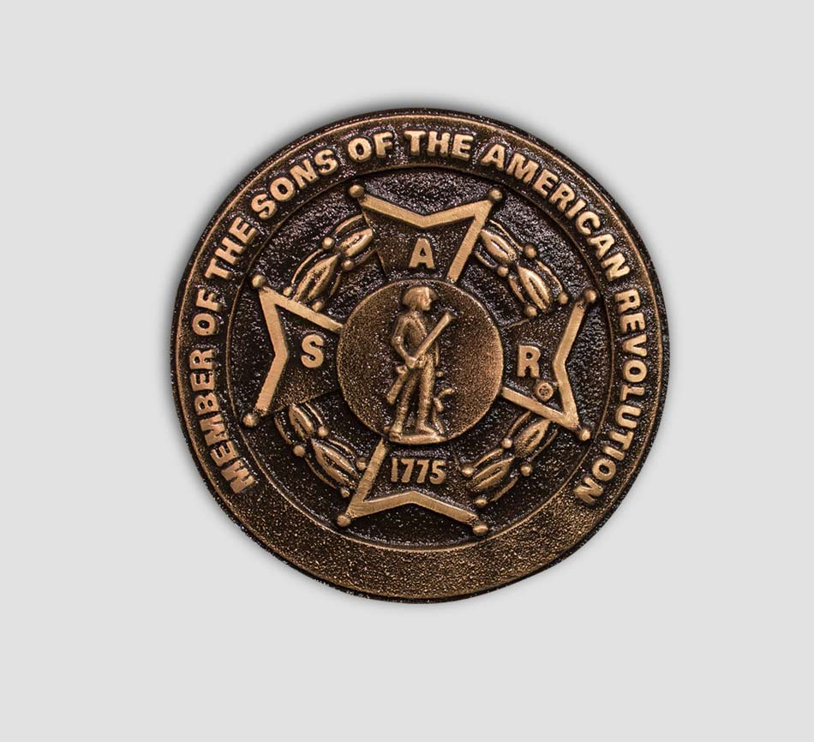
Dr. Lee W. Porter, Captain Robert S. Beckham, Rev Walser Allen
Welcome and Greeting – President, Lower Cape Fear Chapter, SAR
Presentation of Colors – Combined Color Guard
Invocation – Chaplain Charles A. Lewis
Pledge of Allegiance – Compatriot Tom Pearson
SAR Pledge – Compatriot Bob Williamson
We, the descendants of the heroes of the American Revolution, Who, by their sacrifices, established the United States of America, reaffirm our faith in the principles of Liberty and our Constitutional Republic and solemnly pledge ourselves to defend them against every foe.
Introduction to the Daughters of the American Revolution – Regent Jo Stroud
The American's Creed
(Authorized Version by William Tyler Page)
I believe in the United States of American as a government of the people, by the people, for the people; whose just powers are derived from the consent of the governed; a democracy in a republic; a sovereign Nation of many sovereign States; a perfect Union, one and inseparable; established upon those principles of freedom, equality, justice and humanity for which American patriots sacrificed their lives and fortunes.
I therefore believe it is my duty to my country to love it; support its Constitution; to obey its laws; to respect its flag; and to defend it against all enemies.
Introduction to Sons of the American Revolution – Compatriot George Strunk, NC SAR State President
Life of the Compatriot – Dr. Lee W. Porter, Captain Robert S. Beckham, Rev Walser Allen
Commemoration Ceremony – Lower Cape Fear Chapter SAR
Decoration of the Grave
  - Lower Cape Fear Chapter (Wilmington, NC), NCSSAR – John Stewart
  - NC SAR and General George Washington Chapter – George Strunk
  - Stamp Defiance Chapter (Wilmington, NC), NSDAR – Jo Stroud
  - Old North State Chapter NS SAR – Charles A. Lewis
Introduction of family members – John Stewart
Comments by family members
SAR Recessional – Gary O. Green
Until we meet again, let us remember our obligations to our forefathers who gave us our Constitution, the Bill of Rights, an independent Supreme Court, and a nation of free men.
Retiring the Colors - Combined Color Guard
Reception –Olympia Restaurant
Grave marking information
Lee Warwick Porter Jr - 1st Baptist Church Columbarium, 411 Market St, Wilmington, NC 28401-4546 34.23583333 -077.9383333
Captain Robert Strickland Beckham – Wilmington National Cemetery, 2011 Market St, Wilmington, NC 28403-1017 34.23972222 -077.9277778
Rev Walser Haddon Allen, Jr – Oleander Memorial Gardens, 306 Bradley Drive, Wilmington, NC 28409-0000 34.20638889 -077.82888889
Monetary Contributions to the event:
VPG Daniel K. Woodruff, South Atlantic District SAR
Ronald C. Bonham, Gen George Washington Chapter, NC SAR
Broughton L. Goodson, Gen George Washington Chapter, NC SAR
Guy M. Higgins, Daniel Morgan Chapter, SC SAR
C. Kenith Wilson, Halifax Resolves Chapter, NC SAR
James H. Wood, Mecklenburg Chapter, NC SAR

APPENDIX F – Other Grave Marking services handouts
The following programs are listed on the Patriot Records Committee page on the SAR web site [https://sar.org/compatriots/committees/patriot-records-committee] and are provided as examples of Patriot Grave Marking services; they show how various other chapters have conducted services:

Patriot Names Date of Service Location

General William Lee Davidson 28 MAR 2010 Huntersville, NC
COL Frederick Hambright 6 OCT 2009 Grover, NC
MAJ Thomas Young 27 AUG 2011 Union, SC
Rev. Henry Wood 6 MAY 2007 Greer, SC
Harrison Taylor 20 NOV 2011 Hartford, KY
PVT George Plummer 23 OCT 2011 Fleming, KY
COL Richmond Pearson 22 MAR 2009 Cooleemee, NC
LT George Locke 20 AUG 2011 Charlotte, NC
COL William Bratton 24 MAR 2011 York, SC
William Peeples 10 MAR 2012 Chatsworth, GA
William Suttles 8 SEP 2012 Utoy, GA
James Paris 24 MAR 2012 New London, MO
Randolph White 14 AUG 2010 Huntsville, MO
Jonathan Hunt 4 OCT 2010 Nicholas, NY

